**Draw your Home Network Topology and explain how you are accessing the RPS Lab environment.**

**Home Network Topology**

**1. ISP (Internet Service Provider):**

Provides internet access to home.

**2. Modem:**

Connects to the ISP and converts the internasset signal for home use.

**3. Router:**

Distributes the internet connection to various devices within the home network.

**4. Devices:**

Includes computers, smartphones, tablets, smart TVs, and IoT devices connected via Wi-Fi or Ethernet.

**Accessing the RPS Cloud Lab Environment**

**1. Connect to the Router:**

Ensure your device (e.g., computer) is connected to the router via Wi-Fi or Ethernet.

**2. Internet Access:**

The router provides internet access to device through the modem, which is connected to the ISP.

**3. Cloud Lab Access:**

- Open a web browser on device.

- Navigate to the URL of RPS cloud lab environment (e.g., virtual lab setup).

- Authenticate with credentials (username and password).

**4. Utilize the Cloud Lab:**

Once authenticated, can access and use the resources provided by the cloud lab environment.

### **Diagram of Accessing the RPS Cloud Lab Environment**

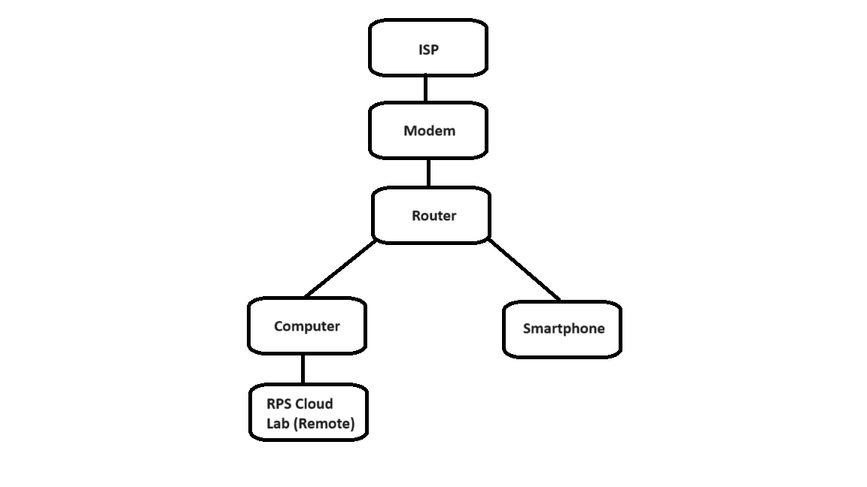

In this setup, the computer (or any device) connects to the router, which provides internet access through the modem and ISP. The cloud lab environment is accessed via the internet, allowing for remote work and resource management.